PRINCESS BEVERLY R. ALA-AN
CSC 112 – BNO1
ASSIGNMENT

- Prove to be a RL using pumping lemma (show proof) and give equivalent automaton if it’s a regular language. (10 pts. Each)

- L = {0^{k}1^{k} | k >= 1}
  - PROOF
    - Assume that L is a regular language;
    - And pumping length = P
    - S = 0^{P}1^{P}, where S is divided into 3 parts S = x y z
    - If P (pumping length) is 6, then S = 000000111111
    - Dividing S into x y z
*Note: highlighted texts ## is x, ## is y, ## is z.
      - Case 1: y is in 0 part
        - S = 00 0000 111111
xy^{i}z ⇒ xy²z
        - x = 00
        - y = 0000 0000
        - z = 111111
        - 0’s = 10
1’s = 6
        - $10 ≠ 6→S∉L$
      - Case 2: y is in 1 part
        - 000000 1111 11
xy^{i}z ⇒ xy²z
        - x = 000000
        - y = 1111 1111
        - z = 11
        - 0’s = 6
1’s = 10
        - $6 ≠ 10→S∉L$
      - Case 3: y is in the ‘0’ and ‘1’ part
        - 0000 0011 1111 x = 00
xy^{i}z ⇒ xy²z
        - x = 0000
        - y = 0011 0011
        - z = 1111
        - S does not follow 0’s1’s pattern. Therefore, $S∉L.$
    - $\left|xy\right|≤P$
      - Case 1: P = 6, x = 2, y = 4
        - $\left|6\right| ≤6. True$
      - Case 2: P = 6, x = 6, y = 4
        - $\left|10\right| ≤6. False$
      - Case 3: P = 6, x = 4, y = 4
        - $\left|8\right| ≤6. False$
    - The following conditions:
      - $xy^{i}z ∈L for every i≥0 is False.$
      - $\left|y\right| >0 is True.$
      - $\left|xy\right|≤P is False.$
$$∴S cannot be pumped==contradicts L is a Regular Language.$$

- L = {w | w contains the substring 001}
  - PROOF
    - Assume that L is a regular language;
    - And pumping length = P
    - String S = 0^{P} 0 0 1 1^{P}, clearly S contains the substring “001”, so $S∉L and \left|S\right| ≥P$
    - If P (pumping length) is 6, then S = 0⁶ 001 0⁶ = 000000 001 000000
This means that the x and y are located within the first P symbols of
S = (0^{P} 0 0 1 1^{P}).
    - Dividing S into x y z
      - Case 1: y is in the leading 0 part
        - S = 00 0000 001000000
xy^{i}z ⇒ xy²z
        - x = 00
        - y = 0000 0000
        - z = 001000000
        - $Specific \text{001} substring remains intact. Therfore, S∉L.$
      - Case 2: y is in the 001 part
        - The “001” part begins after position P. But the condition $\left|xy\right|≤P$ says y ends at or before position P. Hence, y cannot be in the “001” portion.
        - Case 2 is false (impossible)
      - Case 3: y is in the trailing 0s (after the 001)
        - Same reasoning as case 2 meaning y appears before the “001” substring and cannot extend beyond it$.$ So, y cannot be in the trailing 0’s.
        - Case 3 is false (impossible)

Only Case 1 is valid and satisfies the Pumping Lemma for this language.
    - The following conditions:
      - $xy^{i}z ∈L for every i≥0 is True shown in Case 1.$
      - $\left|y\right| >0 is True.$
      - $\left|xy\right|≤P is True.$
$$∴S can be pumped \left(the pumped strings stay in L\right). \\ Threfore, L satisfies the Pumping Lemma and is a Regular Language$$

Automaton Equivalent:
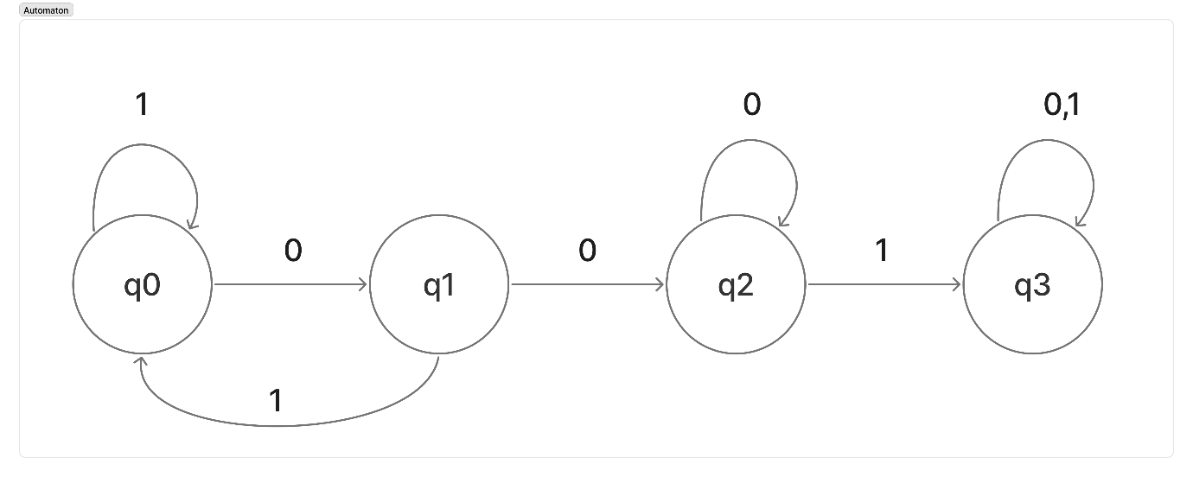
Provide a CFG for the following expressions, and prove that each expression is in L(G) by giving a derivation and the corresponding parse tree. (10 pts. each)
Context-Free Grammar:
G = {V, Σ, R, S}
V = {E, T, F, N}
Σ = {+, -, *, /} ∪ {N | N ∈ ℝ}
S = E
R:

E → E - T | E + T | T
T → T * F | T / F | F
F → E | N

1. 12 / 3 + 2 * 4

Leftmost Derivation of 12 / 3 + 2 * 4:

  - E → E + T {as E → E + T}
  - E → T + T {as E → T}
  - E → T/F + T {as T → T/F}
  - E → F/F + T {as T → F}
  - E → N/F + T {as F → N}
  - E → 12/F + T {as N → 12}
  - E → 12/N + T {as F → N}
  - E → 12/3 + T {as N → 3}
  - E → 12/3 + T * F {as T → T * F}
  - E → 12/3 + F * F {as T → F}
  - E → 12/3 + N * F {as F → N}
  - E → 12/3 + 2 * F {as N → 2}
  - E → 12/3 + 2 * N {as F → N}
  - E → 12/3 + 2 * 4 {as N → 4; End}
LEFT PARSE TREE:

- 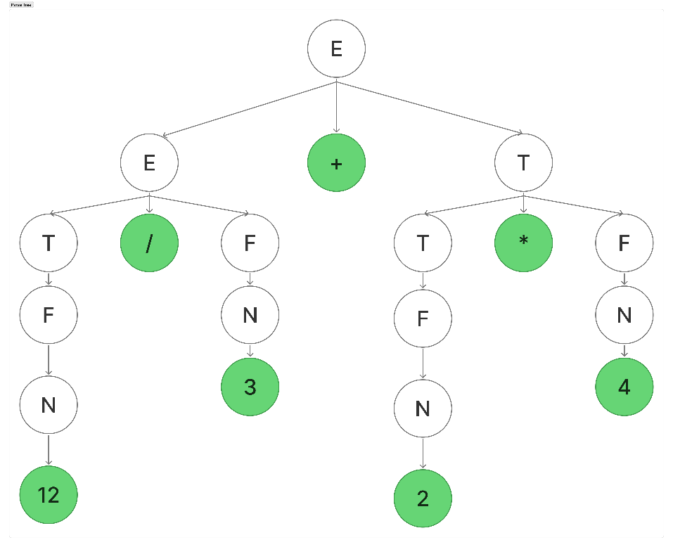
Rightmost Derivation of 12 / 3 + 2 * 4:
- E → E + T {as E → E + T}
- E → E + T * F {as T → T * F}
- E → E + T * N {as F → N}
- E → E + T * 4 {as N → 4}
- E → E + F * 4 {as T → F}
- E → E + N * 4 {as F → N}
- E → E + 2 * 4 {as N → 2}
- E → T + 2 * 4 {as E → T}
- E → T / F + 2 * 4 {as T → T/F}
- E → T / N + 2 * 4 {as F → N}
- E → T / 3 + 2 * 4 {as N → 3}
- E → F / 3+ 2 * 4 {as T → F}
- E → N / 3+ 2 * 4 {as F → N}
- E → 12 / 3+ 2 * 4 {as N → 12}

RIGHT PARSE TREE:



2. 2 * 5 - 2

Leftmost Derivation of 2 * 5 – 2:

- E → T {as E → T}
- E → T – T {as T → T – T}
- E → T * F – T {as T → T * F}
- E → F * F – T {as T → F}
- E → N * F – T {as F → N}
- E → 2 * F – T {as N → 2}
- E → 2 * N – T {as F → N}
- E → 2 * 5 – T {as N → 5}
- E → 2 * 5 – F {as T → F}
- E → 2 * 5 – N {as F → N}
- E → 2 * 5 – 2 {as N → 5; End}
LEFT PARSE TREE:
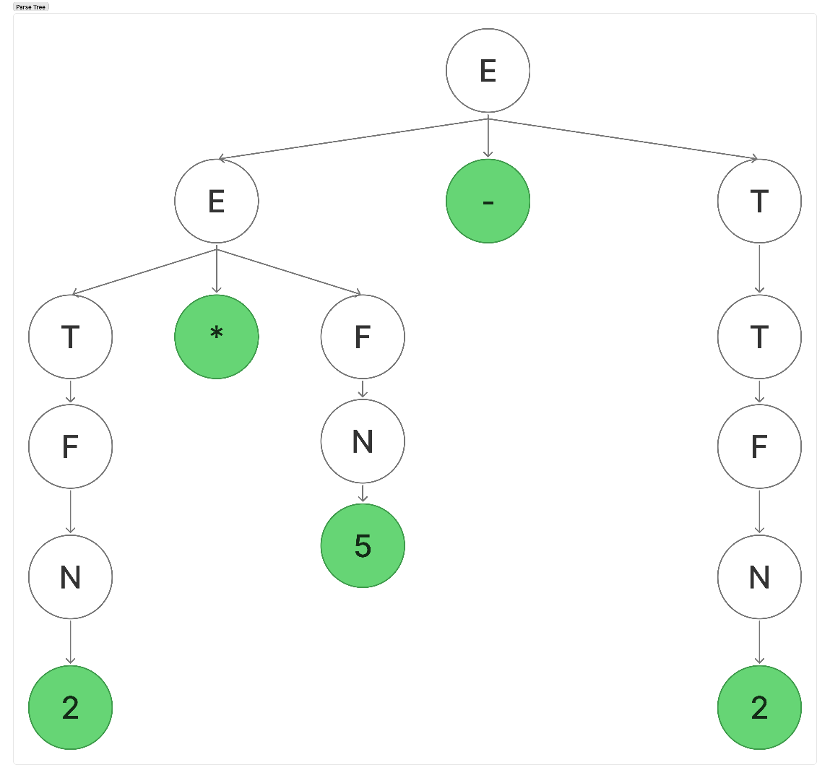

Rightmost Derivation of 2 * 5 – 2:

      - E → T {as E → T}
      - E → T – T {as T → T – T}
      - E → T – F {as T → F}
      - E → T – N {as F → N}
      - E → T – 2 {as N → 2}
      - E → T * F – 2 {as T → T * F}
      - E → T * N – 2 {as F → N}
      - E → T * 5 – 2 {as N → 5}
      - E → F * 5 – 2 {as T → F}
      - E → N * 5 – 2 {as F → N}
      - E → 2 * 5 – 2 {as N → 2; End}
RIGHT PARSE TREE:
